# DCGAN Based Brain Metastases Detection Using Limited Labeled Dataset

*Note: Sub-titles are not captured in Xplore and should not be used

# 1st Given Name Surname

*dept. name of organization (of Aff.) name of organization (of Aff.)*

City, Country

email address or ORCID

# 4th Given Name Surname

*dept. name of organization (of Aff.) name of organization (of Aff.)*

City, Country

email address or ORCID

# 2nd Given Name Surname

*dept. name of organization (of Aff.) name of organization (of Aff.)*

City, Country

email address or ORCID

# 5th Given Name Surname

*dept. name of organization (of Aff.) name of organization (of Aff.)*

City, Country

email address or ORCID

# 3rd Given Name Surname

*dept. name of organization (of Aff.) name of organization (of Aff.)*

City, Country

email address or ORCID

# 6th Given Name Surname

*dept. name of organization (of Aff.) name of organization (of Aff.)*

City, Country

email address or ORCID

***Abstract*—** **Computer-Assisted Diagnosis (CAD) with high sensitivity helps in early diagnosis of Brain tumors. Due to the confidentiality of the medical data, it is not easily accessible. To overcome this problem, Data Augmentation (DA) is one such technique, which helps to generate synthetic data. This data when used along with the training data, helps to handle the small medical image dataset collected from various scanners. Generative Adversarial Networks (GANs) is one of the DA techniques. GAN trained on images can generate new images that contain many authentic characteristics and look realistic to human observers. Therefore, this paper focuses on overcoming the problem of limited labeled dataset, using Deep Convolutional GANs (DCGANs). After combining the synthetic images to the training data, there was an increase in the accuracy by a factor of 13.16. To analyze the closeness between the original and synthetic images, a visualization tool called ImageJ was used. In order to validate the CAD model, a visual turing test was conducted with the help of expert physicians.**

***Index Terms*—component, formatting, style, styling, insert**

1. **INTRODUCTION**

A mass or growth of abnormal cells in the brain leads to brain Tumor. The brain is one of the largest and most complex organs in the human body. Any unexpected growth may affect human function and may spread into other body organs and affect human functions. Detection of brain tumor is very complicated and difficult due to the size, shape, location and type of tumor in the brain, and hence early detection and classification of brain tumor helps in treatment methods. Diagnosis is usually done by medical examination, with Computer Tomography (CT) or Magnetic Resonance Imaging (MRI). MRI is one of the commonly used techniques due to its superior image quality and using no ionizing radiation during the scan. According to the article by The Hindu on June 12 2016, Brain Tumor Foundation of India says that brain tumor is the second most common cancer among children after leukemia. In India, every year 40,000-50,000 persons are diagnosed with brain tumors, out of which 20 percent are children. Until 2015, the figure was only somewhere around 5 percent. According to the official data, currently only six per cent of the children suffering from brain tumors are able to get the proper treatment. Accurate Computer-Assisted Diagnosis, associated with proper data wrangling, can alleviate the risk of overlooking the diagnosis in a clinical environment. However in many situations either data is limited or labeling is limited. Towards this, as a Data Augmentation (DA) technique, Generative Adversarial Networks (GANs) can synthesize additional training data to handle the small/fragmented medical imaging datasets collected from various scanners; those images are realistic but completely different from the original ones, filling the data lack in the real image distribution.

**Contributions**: Our main contributions are as follows:

* To develop a model using Deep Convolutional Generative Adversarial Network (DCGAN) for the synthesis of brain image dataset.
* Evaluate and validate the model

1. **ALGORITHMS & TECHNIQUES**

***A. Generative Adversarial Network (GAN)***

Generative adversarial networks (GANs) are algorithmic architectures that use two neural networks, pitting one against the opposite (thus the “adversarial”) so as to get new, synthetic instances of data that can pass for real data. GAN comprises of two type of neural networks, the generator model and the discriminator model. One neural network, called the generator, generates new data instances, while the opposite the discriminator, evaluates them for authenticity; i.e. the discriminator decides whether each instance of knowledge that it reviews belongs to the particular training dataset or not.

The generator is creating new, synthetic images that it provides as input to the discriminator. It does so within the hopes that they, too, are going to be deemed authentic, albeit they're fake. The goal of the generator is to get passable hand-written digits: to lie without being caught. The goal of the discriminator is to spot images coming from the generator as fake.

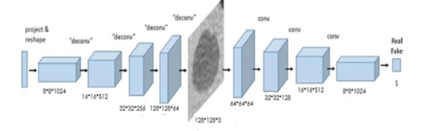

*Figure 1: Generative Adversarial Network Flow Diagram*

***B. Convolutional Neural Network***

Computers see images using pixels. Pixels in images are related to some specific properties. For example, a particular group of pixels may signify a foothold in a picture or another pattern. Convolutions use this to help identify images. A convolution layer multiplies a matrix of pixels with a filter matrix and sums up the multiplication values. Then the convolution slides over to subsequent pixel and repeats an equivalent process until all the image pixels are covered.

1. **MATERIALS AND METHODS**
2. ***Brain Metastases Dataset***

Dataset is retrieved from Kaggle data repository. Dataset contains 253 brain MRI images in which 98 tumor images 155 non-tumor images. For GAN training the entire dataset is used which has 253 images each of size 200*200. For Tumor detection the whole dataset is divided into training, testing and validation set.

* Training Set: 261 Images
* Testing Set: 39 Images
* Validation Set: 38 Images

1. ***DCGAN based image generation***

**The generator model** starts with the image size of 8*8 with the 1024 number of filters, and then the batch normalization is done using the LeakyReLU activation function. The image is up scaled to16*16 with 512 filters, and then batch normalization is applied using LeakyReLU activation function. This cycle continues for 2 more times the images is up scaled to32*32 and then to 128*128 and the batch normalization is applied using LeakyReLU activation function at last the hyperbolic tangent activation function is applied.

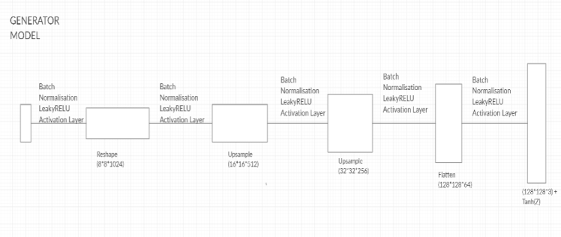

*Figure 2: Generator Model*

**The discriminator model** breaks down the images in reverse order as the generator model constructed it from 128*128 to 8*8 with batch normalization using LeakyReLU function with the same number of filters at each step.

**Activation functions** such as ReLU are used to address the vanishing gradient problem in deep convolutional neural networks and promote sparse activations (e.g. lots of zero values).The generator uses the hyperbolic tangent (tanh) activation function in the output layer and inputs to the generator and discriminator are scaled to the range [-1, 1].For the discriminator, the last convolution layer is flattened and then fed into a single sigmoid output.

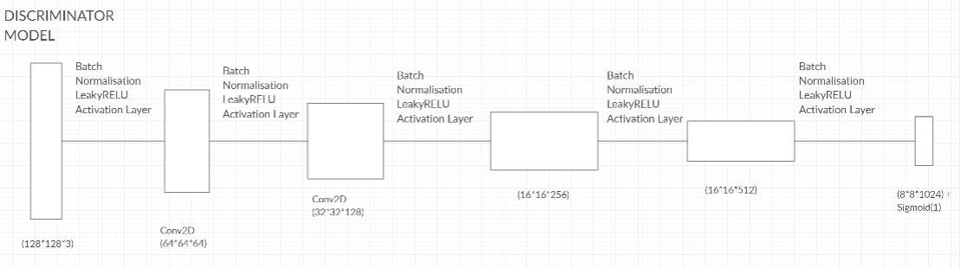

*Figure 3: Discriminator Model*

1. ***Convolutional Neural Network based detection***

**Sequential model** in supervised learning can be used for many application that deals with detection.

The model uses “ReLu” activation function and pooling layer “MaxPooling2D” in each convolutional layer.

MaxPooling2D : It down samples the input representation by taking the maximum value over the window defined by pool size for each dimension along the features axis. The window is shifted by strides in each dimension.

Equation 1 represents the Loss Function used in the final layer that is Binary Cross Entropy loss function.

|  |
| --- |
|  |

$$C E=\sum_{i=1}^{C^{'}}{t_{i}\log\left(f\left(s_{i}\right)\right)=-t_{i}\log\left(f\left(s_{1}\right)\right)-\left(1-t_{1}\right)log⁡(1-f\left(s_{1}\right))}$$

This type of loss function involves sigmoid activation and Cross-Entropy loss. It does not depend on each vector component, it elaborates that the loss computed for every CNN output vector component is not affected by other component values. This was the reason for it to be used for multi-label classification, were the insight of an element belonging to a certain class should not influence the decision for another class.

Where ti (target vector) and si (softmax function) are the ground truth and the CNN score for each class i in Class C.

**The optimizer** used in this sequential model is Rmsprop optimizer. These Optimizers are used to change the attributes of your neural network such as weights and learning rate in order to reduce the losses. Thisoptimizer utilizes the magnitude of recent gradients to normalize the gradients.

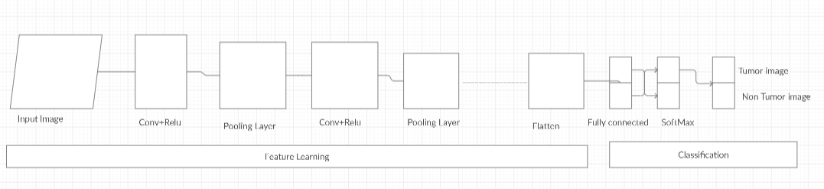

*Figure 4: CNN Sequential Model Architecture.*

Now the next step is computation of metrics such as specificity, sensitivity, accuracy, etc. which are essential in calculating the accuracy and making predictions.

**Specificity** is defined as the proportion of actual negatives, which got predicted as the negative.

*Specificity*= (True Negative)/ (True Negative + False Positive)

**True Negative (TN)** = Persons predicted as not having brain tumor are actually found to be not having a brain tumor (healthy) (True Negative + False Positive)

**False Positive (FP)** = Persons predicted of having brain tumor are actually found to be not having brain tumor (healthy).

Sensitivity is a measure of the proportion of actual positives that got predicted as positive.

***Sensitivity*** = (True Positive)/ (True Positive + False Negative)

**True Positive (TP)** = Persons predicted as are actually have brain tumor.

**False Negative (FN)** = Persons who are actually suffering from the brain tumor disease are actually predicted to be not suffering from the brain tumor disease (healthy).

**Accuracy** = the nearness of a calculation to the true value . The formula for accuracy is: ((TP+TN)/ (TP+TN+FP+FN)).

**Efficiency** = (sensitivity + specificity + Accuracy) / 3

**Precision**= precision is the resolution of the representation, typically defined by the number of decimal or binary digits. The formula for accuracy is TP / (TP+FP)

**Recall**=TP / (TP+FN)

**F1 score** is defined as the harmonic mean between precision and recall. It is used as a statistical measure to rate performance.

1. ***Clinical Validation via Visual Turing Test***

To validate the model, we took help of two expert physicians. We combined 100 original and 87 synthetic images and gave them to the physician to differentiate between original and synthetic images. This experiment was done mainly because the validation via technical methods might provide good results, whereas the validation through experts who have immense experience in that field would provide much more scope in order to improve the model efficiency. This experiment was conducted in a timely manner and the outcome of the experiment was used to update the existing model and improve the efficiency.

1. ***Visualization via imageJ***

ImageJ is image processing tool used to compare profiles of original and synthetic images. It can create histograms and line profile plots. It supports image processing functions like contrast manipulation, convolution, Fourier analysis, sharpening, smoothing and edge detection.

Histogram. Calculates and displays a histogram of the distribution of grey values within the active image or selection. The x-axis represents the possible grey values and the y-axis shows the number of pixels found for each grey value

Plot Profile

This type of plot displays a two-dimensional graph of the intensities of pixels along a line within the image. The x-axis represents distance along the line and the y-axis is the pixel intensity.

*Abbreviations and Acronyms*

Define abbreviations and acronyms the first time they are used in the text, even after they have been defined in the abstract. Abbreviations such as IEEE, SI, MKS, CGS, ac, dc, and rms do not have to be defined. Do not use abbreviations in the title or heads unless they are unavoidable.

1. *Units*
   * Use either SI (MKS) or CGS as primary units. (SI units are encouraged.) English units may be used as secondary units (in parentheses). An exception would be the use of English units as identifiers in trade, such as “3.5-inch disk drive”.
   * Avoid combining SI and CGS units, such as current in amperes and magnetic field in oersteds. This often leads to confusion because equations do not balance dimensionally. If you must use mixed units, clearly state the units for each quantity that you use in an equation.
   * Do not mix complete spellings and abbreviations of units: “Wb/m2” or “webers per square meter”, not “webers/m2”. Spell out units when they appear in text: “. . . a few henries”, not “. . . a few H”.
   * Use a zero before decimal points: “0.25”, not “.25”. Use “cm3”, not “cc”.)
2. *Equations*

Number equations consecutively. To make your equations more compact, you may use the solidus ( / ), the exp function, or appropriate exponents. Italicize Roman symbols for quantities and variables, but not Greek symbols. Use a long dash rather than a hyphen for a minus sign. Punctuate equations with commas or periods when they are part of a sentence, as in:

*a* + *b* = *γ* (1)

Be sure that the symbols in your equation have been defined

before or immediately following the equation. Use “(1)”, not

“Eq. (1)” or “equation (1)”, except at the beginning of a sentence: “Equation (1) is . . .”

1. *LATEX-Specific Advice*

Please use “soft” (e.g., \eqref{Eq}) cross references instead of “hard” references (e.g., (1)). That will make it possible to combine sections, add equations, or change the order of figures or citations without having to go through the file line by line.

Please don’t use the {eqnarray} equation environ- ment. Use {align} or {IEEEeqnarray} instead. The

{eqnarray} environment leaves unsightly spaces around relation symbols.

Please note that the {subequations} environment in LATEX will increment the main equation counter even when there are no equation numbers displayed. If you forget that, you might write an article in which the equation numbers skip from (17) to (20), causing the copy editors to wonder if you’ve discovered a new method of counting.

BIBTEX does not work by magic. It doesn’t get the biblio- graphic data from thin air but from .bib files. If you use BIBTEX to produce a bibliography you must send the .bib files.

LATEX can’t read your mind. If you assign the same label to a subsubsection and a table, you might find that Table I has been cross referenced as Table IV-B3.

LATEX does not have precognitive abilities. If you put a

\label command before the command that updates the

counter it’s supposed to be using, the label will pick up the last counter to be cross referenced instead. In particular, a \label command should not go before the caption of a figure or a table.

Do not use \nonumber inside the {array} environment. It will not stop equation numbers inside {array} (there won’t be any anyway) and it might stop a wanted equation number in the surrounding equation.

1. *Some Common Mistakes*
   * The word “data” is plural, not singular.
   * The subscript for the permeability of vacuum *µ*0, and other common scientific constants, is zero with subscript

formatting, not a lowercase letter “o”.

* + In American English, commas, semicolons, periods, ques- tion and exclamation marks are located within quotation marks only when a complete thought or name is cited, such as a title or full quotation. When quotation marks are used, instead of a bold or italic typeface, to highlight a word or phrase, punctuation should appear outside of the quotation marks. A parenthetical phrase or statement at the end of a sentence is punctuated outside of the closing parenthesis (like this). (A parenthetical sentence is punctuated within the parentheses.)
  + A graph within a graph is an “inset”, not an “insert”. The word alternatively is preferred to the word “alternately” (unless you really mean something that alternates).
  + Do not use the word “essentially” to mean “approxi- mately” or “effectively”.
  + In your paper title, if the words “that uses” can accurately replace the word “using”, capitalize the “u”; if not, keep using lower-cased.
  + Be aware of the different meanings of the homophones “affect” and “effect”, “complement” and “compliment”, “discreet” and “discrete”, “principal” and “principle”.
  + Do not confuse “imply” and “infer”.
  + The prefix “non” is not a word; it should be joined to the word it modifies, usually without a hyphen.
  + There is no period after the “et” in the Latin abbreviation “et al.”.
  + The abbreviation “i.e.” means “that is”, and the abbrevi- ation “e.g.” means “for example”.

An excellent style manual for science writers is [7].

1. *Authors and Affiliations*

**The class file is designed for, but not limited to, six authors.** A minimum of one author is required for all confer- ence articles. Author names should be listed starting from left to right and then moving down to the next line. This is the author sequence that will be used in future citations and by indexing services. Names should not be listed in columns nor group by affiliation. Please keep your affiliations as succinct as possible (for example, do not differentiate among departments of the same organization).

1. *Identify the Headings*

Headings, or heads, are organizational devices that guide the reader through your paper. There are two types: component heads and text heads.

Component heads identify the different components of your paper and are not topically subordinate to each other. Examples include Acknowledgments and References and, for these, the correct style to use is “Heading 5”. Use “figure caption” for your Figure captions, and “table head” for your table title. Run-in heads, such as “Abstract”, will require you to apply a style (in this case, italic) in addition to the style provided by the drop down menu to differentiate the head from the text.

Text heads organize the topics on a relational, hierarchical basis. For example, the paper title is the primary text head because all subsequent material relates and elaborates on this one topic. If there are two or more sub-topics, the next level head (uppercase Roman numerals) should be used and, conversely, if there are not at least two sub-topics, then no subheads should be introduced.

1. *Figures and Tables*

*a) Positioning Figures and Tables:* Place figures and tables at the top and bottom of columns. Avoid placing them in the middle of columns. Large figures and tables may span across both columns. Figure captions should be below the figures; table heads should appear above the tables. Insert figures and tables after they are cited in the text. Use the abbreviation “Fig. 1”, even at the beginning of a sentence.

TABLE I

TABLE TYPE STYLES

|  |  |  |  |
| --- | --- | --- | --- |
| **Table**  **Head** | **Table Column Head** | | |
| ***Table column subhead*** | ***Subhead*** | ***Subhead*** |
| copy | More table copya |  |  |

aSample of a Table footnote.



Fig. 1. Example of a figure caption.

Figure Labels: Use 8 point Times New Roman for Figure labels. Use words rather than symbols or abbreviations when writing Figure axis labels to avoid confusing the reader. As an example, write the quantity “Magnetization”, or “Magnetiza- tion, M”, not just “M”. If including units in the label, present them within parentheses. Do not label axes only with units. In the example, write “Magnetization (A/m)” or “Magnetization A[m(1)] ”, not just “A/m”. Do not label axes with a ratio of quantities and units. For example, write “Temperature (K)”, not “Temperature/K”.

*{ }*

ACKNOWLEDGMENT

The preferred spelling of the word “acknowledgment” in America is without an “e” after the “g”. Avoid the stilted expression “one of us (R. B. G.) thanks *. . .*”. Instead, try “R. B. G. thanks*. . .*”. Put sponsor acknowledgments in the unnumbered footnote on the first page.

REFERENCES

Please number citations consecutively within brackets [1]. The sentence punctuation follows the bracket [2]. Refer simply to the reference number, as in [3]—do not use “Ref. [3]” or “reference [3]” except at the beginning of a sentence: “Reference [3] was the first *. . .*”

Number footnotes separately in superscripts. Place the ac- tual footnote at the bottom of the column in which it was cited. Do not put footnotes in the abstract or reference list. Use letters for table footnotes.

Unless there are six authors or more give all authors’ names; do not use “et al.”. Papers that have not been published, even if they have been submitted for publication, should be cited as “unpublished” [4]. Papers that have been accepted for publication should be cited as “in press” [5]. Capitalize only the first word in a paper title, except for proper nouns and element symbols.

For papers published in translation journals, please give the English citation first, followed by the original foreign-language citation [6].

REFERENCES

[1]G. Eason, B. Noble, and I. N. Sneddon, “On certain integrals of Lipschitz-Hankel type involving products of Bessel functions,” Phil. Trans. Roy. Soc. London, vol. A247, pp. 529–551, April 1955.

[2]J. Clerk Maxwell, A Treatise on Electricity and Magnetism, 3rd ed., vol.

2. Oxford: Clarendon, 1892, pp.68–73.

[3]I. S. Jacobs and C. P. Bean, “Fine particles, thin films and exchange anisotropy,” in Magnetism, vol. III, G. T. Rado and H. Suhl, Eds. New York: Academic, 1963, pp. 271–350.

[4]K. Elissa, “Title of paper if known,” unpublished.

[5]R. Nicole, “Title of paper with only first word capitalized,” J. Name Stand. Abbrev., in press.

[6]Y. Yorozu, M. Hirano, K. Oka, and Y. Tagawa, “Electron spectroscopy studies on magneto-optical media and plastic substrate interface,” IEEE Transl. J. Magn. Japan, vol. 2, pp. 740–741, August 1987 [Digests 9th Annual Conf. Magnetics Japan, p. 301, 1982].

[7]M. Young, The Technical Writer’s Handbook. Mill Valley, CA: Univer- sity Science, 1989.

IEEE conference templates contain guidance text for compos- ing and formatting conference papers. Please ensure that all template text is removed from your conference paper prior to submission to the conference. Failure to remove the template text from your paper may result in your paper not being published.